Press Announcement

Smart Cities: Eliminating Data Silos with Open Source Technology
A freely accessible digital twin for smart cities enables functions and services for cities in real time – EDAG PS implements pilot project in Paderborn

May 10, 2022

EDAG Production Solutions GmbH & Co. KG (EDAG PS) is a "gold member" of the FIWARE Foundation. This groundbreaking, global open source initiative enhances the design of sustainable digital platforms for the smart city ecosystem. Cities and municipalities benefit from standardized data models and interfaces (APIs) based on transparent and standard open source technologies. EDAG PS has already used these to implement successful smart city concepts.
FIWARE is a non-profit-making association which was founded in 2016 with the aim of promoting smart solutions in a faster, simpler and interoperable way. The members of the initiative are committed to "building an open, sustainable ecosystem based on public, free of charge, implementation-oriented software platform standards. These should facilitate the development of new smart applications in various fields."
Working on this basis, EDAG PS brings the city, its citizens and the mobility of the future closer together. With the EDAG CityBot and its integration into the complete ecosystem of tomorrow's urban structures, the largest independent technology developer in the field of mobility is one of the pacemakers of the smart city. The particular focus here is on software and digitalization. As a "gold member" of the FIWARE Foundation, EDAG PS is now applying these skills to its global ecosystem.
"With our CityBot and Smart City projects, our aim is to work together with municipalities and civic institutions to further improve the quality of urban life," explains EDAG PS CEO Dirk Keller. A crucial point here is the use of information and communication technologies (ICT), which nowadays make it easier than ever for cities to build data platforms.
"This means that the digital foundations have been laid to enable people to obtain real-time information about what is going on in their city. What is more, in smart government, decisions can also be made and optimizations carried out on the basis of concrete datasets. This is a win-win situation for everyone and takes the quality of the relationship between citizens, government and service providers to a new level."
Paderborn uses dashboard for smart cities
One of the greatest challenges in implementation is that many data providers and IoT devices only have proprietary interfaces. This means that connection to a central data platform, if feasible at all, is a very complex and expensive undertaking. "This problem was detected some time ago, and gave rise to FIWARE, the open source platform technology for our smart digital future," explains FIWARE CEO Ulrich Ahle. "Our solution involves freely usable software components for processing context data, which facilitate communication between different subsystems in and on the data platform. As this is an open source initiative, the strengths and special skills of our more than 500 members from 77 nations - now including EDAG PS - are put to effect here for the benefit of everyone."
In Paderborn, for example, where in cooperation with the city, EDAG PS has helped to get the open-source project "Dashboards for Smart Cities" off the ground. The dashboard displays city functions and services in real-time, so involving interested members of the public in the improvement of everyday city life. Using a simple ticket system in the citizens portal, the dashboard can be used to report cases of garbage or damage (such as trash cans that have fallen over, broken sidewalk slabs) in the city.
"The digital twin provides digital support for different areas of urban life and a complete reference architecture for smart cities," emphasize Dirk Keller. "This enables us to make it as easy as possible for municipalities to host a data platform and connect up to a dashboard. This, in turn, can be easily adapted to the CI of the municipality concerned."
For the CEO of EDAG PS, this marks an important milestone: "The smart city and its digital twin are successful because they follow the principle 'from practical experience for practical application'." The data was collected and processed on an open source basis in accordance with the FIWARE concept. As a result, it is just as easy for other cities and municipalities to use the dashboard as it is for additional new services to be connected.
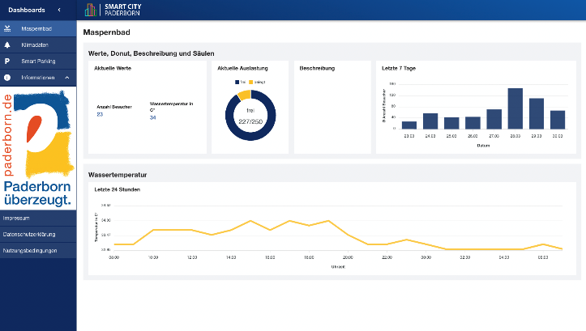
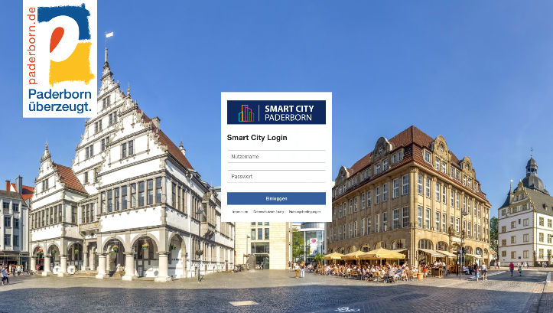
Images: Dashboard of the city of Paderborn

About EDAG
EDAG is the world's largest independent engineering service provider to the global mobility industry.
We regard mobility as a fully integrated ecosystem, and offer our customers technological solutions for more sustainable, emission-free and intelligently networked mobility.
With a global network of some 60 branches, EDAG provides engineering services in the Vehicle Engineering, Electrics/Electronics and Production Solutions segments.
With our interdisciplinary expertise in the fields of software and digitalization, we possess the key skills to help actively shape the dynamic transformation process the mobility industry is currently undergoing. Digital features, autonomous driving, artificial intelligence, alternative powertrains, new mobility concepts and the vision of a networked smart city have become an integral part of our portfolio. Embedded in EDAG's own 360° degree approach to the development of complete vehicles and production facilities, we are a competent partner for sustainable mobility projects. It is in the DNA of the company to actively shape the future of mobility and transfer new technologies and concepts into series production. Today, EDAG is one of the TOP 20 IT service providers in the German mobility sector.
Our customers include leading international OEMs, tier 1 suppliers and startup companies from the automotive and non-automotive industries, all of whom we serve globally with our workforce of approximately 8,000 experts in 360-degree engineering.
In 2021, the company generated sales of € 687 million. On December 31, 2021, EDAG employed a global workforce of 7,880 (including apprentices).

Do you have any questions, or need further information?
I look forward to hearing from you:
Felix Schuster Head Office
Head of Marketing & Communications EDAG Engineering GmbH
Cell phone: +49 173 7345473 Kreuzberger Ring 40
Email: felix.schuster@edag.com 65205 Wiesbaden
www.edag.com

